Who we are and how we are governed?
Active Black Country (ABC) Limited is the Government and Sport England recognised Active Partnership (AP) for the Black Country region, providing the strategic leadership for sport and physical activity across the areas of the Metropolitan Boroughs of Dudley, Sandwell, and Walsall, the City of Wolverhampton, and surrounding areas. In providing a clear vision, the ABC Ltd Board of Directors enables delivery of the Black Country ABC Strategic Plan – ‘Creating an Active Black Country’.
ABC Ltd is registered with Companies House as a company limited by guarantee under company number; 14537800 and a registered charity with the Charity Commission under charity number; 1210894.

The objects of the charity are for the benefit of the public in the Metropolitan Boroughs of Dudley, Sandwell, and Walsall, the City of Wolverhampton, and the surrounding areas:

To preserve and protect good health including but not exclusively through raising awareness of, and promoting, opportunities for participation in physical activity, sport, and recreation;

relieve those in need by reason of youth, age, ill-health, disability, financial, or other disadvantage, including but not exclusively through promoting the provision of facilities, services, and infrastructure for, and making grants to facilitate participation in, physical activity, sport, and recreation;

to advance education in the subjects of sport, physical activity, and recreation; including but not exclusively by carrying out and publishing research and through providing training programs, courses, and the development of resources; and

to promote community participation in healthy recreation through the facilitation of community participation in physical activity and recreation, including but not exclusively by the coordination of sporting, recreational and physical activities capable of promoting good health.

The Active Black Country Ltd Board have the power to establish the overall strategy for our organisation and establish committee structures. The diagram below outlines our governance structure.
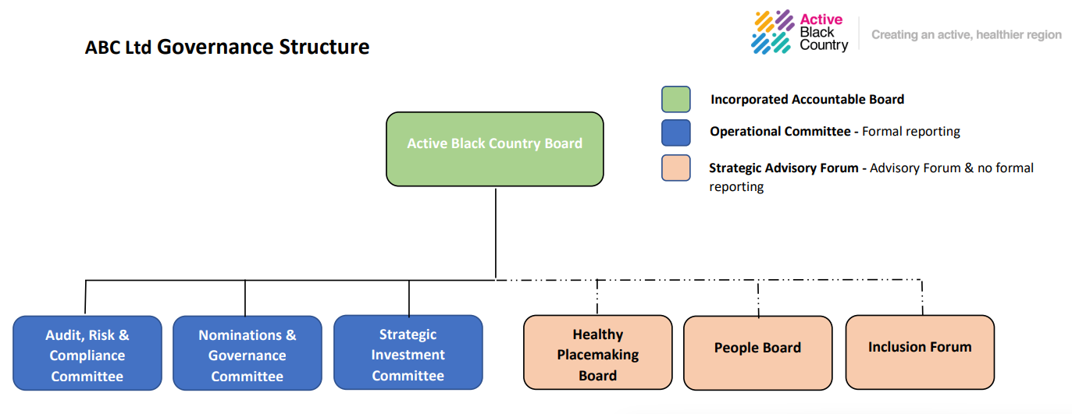

There are currently 8 Board Members serving on the ABC Partnership Board. Up to 12 directors are permitted under Company Articles 24.1. All individuals appointed onto the ABC Ltd Board of Directors are simultaneously:

    - the Directors of the Company under company law and registration with Companies House;
    - the Trustees under charitable law and regulation by the Charity Commission for England & Wales. (upon successful registration with the Charity Commission)

The Independent Directors are the voting Members of the Company, with reserved powers:

    - to approve any amendments to ABC Ltd’s Articles of Association; and to

As set out in Article 27.1 of the Articles of Association of Active Black Country Limited (ABC Ltd, or the Company, or the Charity) dated [date], the Board of Directors:

    - is to manage the business of the Charity; and
    - may exercise all the powers of the Charity, unless the Directors are subject to any restrictions imposed by the Companies Acts, the Articles, or any Special Resolution passed by the Members of the Company.

The quorum for the ABC Ltd Board stipulates at least 6 Independent Directors of the Board must be present in order for business to be transacted, as set out in Article 13.2 of the ABC Ltd Articles of Association.
A Data Protection Officer was appointed in April 2024. In December 2024 a data breach was identified but following an investigation it was deemed to be reportable.
Links to supporting documentation:
Terms of Reference
Who is on our Board and what do they discuss?
Name and Biographies for all Board members - Meet our Board – Active Black Country
Declaration of Interest Form Active Black Country Board - Meet our Board – Active Black Country
In 2024/25 there have been 7 Board meetings, 7 meetings of the Nominations & Governance Committee, 6 meetings of the Audit, Risk & Compliance Committee and 6 meetings of the Strategic Investment Committee.
Minutes of the ABC Ltd Board are available - ABC Board Meetings - ActiveBlackCountry

How we take decisions
The Schedule of Matters Reserved for the ABC Ltd Trustee’s & Scheme of Delegation has been developed to clarify the respective responsibilities and powers of the Active Black Country Board of Trustee’s, committees, and executive officers; to ensure compliance with charity law, other legal requirements and the 2021 Code for Sports Governance.
Scheme of Delegation
In line with the Scheme of Delegation there are currently there are 3 committees with delegated authority:
- Nominations & Governance Committee - to oversee the effectiveness and evaluation processes for the ABC Ltd Board and Board Committees, ensuring ABC Ltd recruitment, selection, training, and development and evaluation processes are conducted in line with the Tier 3 Requirements of the UK Code for Sports Governance.
- Audit, Risk & Compliance Committee - to support the Board to oversee the activities of the charity at a strategic level with regard to financial and non-financial controls, internal and external audit, regulatory compliance, and risk management matters.
- Strategic Investment Committee - to support the Board through robust assurance regarding the programme investment for which ABC Ltd is the accountable body. Ensuring this investment delivers maximum value, meeting the criteria determined by the committee and the desired strategic objectives and evaluation & learning outcomes for Active Black Country & local partners.
How we develop our Board?
The Nominations & Governance Committee leads on the recruitment and selection process with support of the Chief Executive Officer. The Nominations & Governance committee makes proposals to the ABC Board for approval. The key functions of the ABC Ltd Nominations & Governance Committee are:
    - to oversee the recruitment and selection processes for the ABC Ltd:

      - Chair;
      - Vice Chair;
      - Senior Independent Director (SID);
      - Other Independent Directors;
      - Independent Non-Director Members of Board Committees; and
      - Chief Executive Officer (CEO).

    - to ensure ABC Ltd recruitment, selection, training, and evaluation processes are conducted in line with the Tier 3 Requirements of the UK Code for Sports Governance;

    - to oversee the effectiveness evaluation processes for the ABC Ltd Board and Board Committees;

    - to ensure the composition of the ABC Board and Board Committees is reflective of the diversity, inclusiveness, and demographic profile of the Black Country;

    - to oversee the training and continuing professional development processes for the ABC Ltd Board, Board Committees; and Senior Leadership Team; and

The Board succession plan is informed by the annual skills matrix which is regularly reviewed in line with the needs of the Board & Active Black Country business objectives. This was completed in February 2025.
Active Black Country Board values diversity and is committed to promoting equality of opportunity for all. In line with Sport England’s ‘A Code for Sports Governance’, recruitment and engagement with people with appropriate diversity, independence skills, experience and knowledge take place to ensure effective decisions that further the organisation’s goals. Active Black Country demonstrate a strong and public commitment to progressing towards greater diversity on our Board.
The aim of Active Black Country is to promote and achieve a board that reflects the Black Country. Applications from under-represented groups are encouraged and a policy of ‘positive action’ is pursued in an attempt to achieve this.
The Diversity & Inclusion Action Plan (DIAP), updated March 2025, outlines the current approach to ensure that the partnership seeks to foster all aspects of diversity within its leadership and decision making.
Nominations & Governance Terms of Reference

How we review our governance ?
We complete an annual review of the ABC Board member skills, with this most recently completed in February 2025.
Active Black Country Board members have a responsibility to learn about their role and to keep their knowledge and skills up-to-date. The Executive will support them in this by providing them with an induction programme, and training and development on an ongoing basis with an annual appraisal to discuss their performance and future needs.
Members Handbook
The Board undertake annual appraisals of its members and of the effectiveness of the skills and experience therein. The Chair meets with board members yearly to complete an appraisal. An example form is attached. The Chairs appraisal is undertaken by the Vice Chair / Senior Independent. The Chairs Appraisal has been completed and was signed off by. The Active Black Country Chair has completed individual board members appraisals in August 2024.
How we manage risk & conflict?
The partnership has a risk policy & framework that has been approved by the ABC Ltd Board. This is reviewed annually by the ABC Audit, Risk & Compliance committee. Risk reporting is completed to the ABC Ltd Board on a quarterly basis.
An annual external audit is being completed by Folkes Wharton.
Active Black Country is committed to ensuring that all Board Members and Officers act in line with the Nolan Principles of public life.
The Board Handbook provides the detail of how Board Members and Officers should consider conflicts of interest and declare any interests in line with the required processes. The conflict-of-interest policy explains the procedures through which Active Black Country will seek to maintain its high ethical standards and protect its reputation against any allegations of conflict of interest.
It is communicated to everyone involved in Active Black Country to ensure their commitment to it and it applies to all staff and Board Members. Board Members and staff take personal responsibility for declaring their interests and avoiding perceptions of bias. To demonstrate this all-Board Members and staff produce and sign a register of interests and publication on the website which is reviewed every twelve and updated regularly.
Risk Policy
Audit Risk & Compliance Terms of Reference

